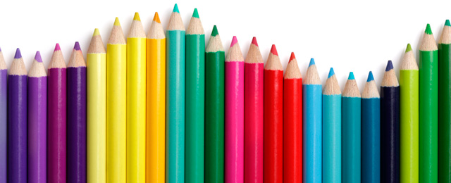

Materials List P1EN
- School bag without wheels (too dangerous on the stairs)

- Pencil case with 2 zippers containing:
  - 6 large silver pencils HB
  - Sharpener with box
  - Scissors with rounded points
  - 1 large white rubber
  - 4 large sticks of glue (40g) – 3 to be kept in stock
  - Packet of 12 coloured pencils
  - Packet of felt tip colour markers
  - 20cm plastic ruler

- Stationary:
  - A4 size *document folder* 80 pages BLUE
* a document folder is called a ‘porte vue’ in French
  - A4 size *document folder* 80 pages RED
  - A4 size *document folder* 80 pages GREEN
  - A4 size *document folder* 80 pages BLACK
  - 1 plastic folder with elastics 24x32cm

- Other items:
  - 1 large old T-shirt for Art
  - 1 box of 12 watercolour paint
  - Gym shoes in a small bag for Sport
  - 1 non-disposable water bottle
  - 2 large boxes of tissues
  - Little German Math Book: Zahlenfuchs 1 (ISBN: 978-3-939965-206)

Please ensure that all items are clearly labelled with your child’s name.
Thank you for your co-operation,
Ms. Hynes

