Pupil Equipment list 2022/23
(P4 – English – Mrs Harriman)

Dear Parents,
Please re-use materials from P3 if they are still in good condition.

Please name as much of the equipment as possible (notably – FRIXON pen, exercise books, novels)

1 small school bag without wheels. (Apart from on the first day, bags do not need to be large, as they normally only need to contain a reading book, a pencil case, and a homework book.)

3 exercise books (red, yellow, green) – Single lined with a margin on the left (see below) , about 96 pages . 24 x 32 cm. *
*Please buy a good quality brand such as Clairefontaine
I exercise book (blue) – containing squared paper (petit carreaux)24 x 32cm, 96 pages *

An A4 folder with elastic (used for storing papers)

1 dictionary (not picture dictionary ). Collins or Oxford dictionaries are the best choice.
1 school thesaurus. (Oxford is a good publisher)
1 Oxford International Primary Atlas (ISBN 978 0 19 8321538)

1 USB key (please make sure it is clearly marked with your child’s name)

Novels :
The Butterfly Lion by Michael Morpurgo
The Midnight Fox by Betsy Byars
Castle Diary – The Journal of Tobias Burgess by Richard Platt
You should be able to buy these books on Amazon (Feel free to buy used copies)

1 pencil case containing:
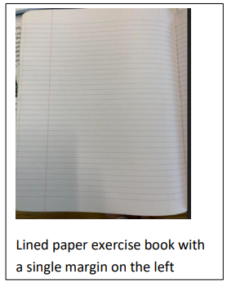

2 HB pencils
1 white eraser
1 pencil sharpener with a collector
1 writing pen - erasable (FRIXON – these)
1 medium whiteboard marker
1 pair of scissors
1 large glue stick
1 green biro (e.g. ‘Bic’) - self correction
1 red biro (e.g. ‘Bic’) - underlining of date and titles

1 30cm ruler (not metal)
1 small whiteboard

1 old shirt/t shirt etc. for use in art.
1 2B drawing pencil (sketching use only)
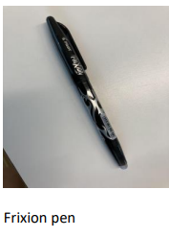
1 pack of coloured pencils

1 box of tissues
1 pair of trainers for use in sport (not plimsolls)
1 water bottle

